Bahria University,

Karachi Campus



COURSE: CSC-113 COMPUTER PROGRAMMING

TERM: FALL 2019, CLASS: BSE- 1 (B)

Submitted By:

M MUAZ SHAHZAD 02-131202-081

(Name) (Reg. No.)

Submitted To:

Engr. Adnan ur rehman/ Engr. Ramsha Mashood

Signed Remarks: Score:

INDEX

|  |  |  |  |  |
| --- | --- | --- | --- | --- |
| SNO | DATE | LAB NO | LAB OBJECTIVE | SIGN |
| 01 | 27-OCT-2020 | 05 | OPERATORS AND EXPRESSIONS |  |
|  |  |  |  |  |
|  |  |  |  |  |
|  |  |  |  |  |
|  |  |  |  |  |
|  |  |  |  |  |
|  |  |  |  |  |
|  |  |  |  |  |
|  |  |  |  |  |
|  |  |  |  |  |
|  |  |  |  |  |
|  |  |  |  |  |
|  |  |  |  |  |
|  |  |  |  |  |
| SNO | DATE | LAB NO | LAB OBJECTIVE | SIGN |
|  |  |  |  |  |
|  |  |  |  |  |
|  |  |  |  |  |
|  |  |  |  |  |
|  |  |  |  |  |
|  |  |  |  |  |
|  |  |  |  |  |
|  |  |  |  |  |
|  |  |  |  |  |
|  |  |  |  |  |
|  |  |  |  |  |
|  |  |  |  |  |
|  |  |  |  |  |
|  |  |  |  |  |
|  |  |  |  |  |

Bahria University,

Karachi Campus



LAB EXPERIMENT NO.

**06**

LIST OF TASKS

|  |  |
| --- | --- |
| TASK NO | OBJECTIVE |
| **01** | Which of the following values can be assigned to variables of type float, double and decimal: 5, -5.01, 34.567839023; 12.345; 8923.1234857; 3456.091124875956542151256683467? |
| 02 | Create a simple calculator which will perform all arithmetical, Bit wise operation and logical operation on two number |
| 03 | Create a simple program to calculate Hypotenuse using Pythagoras theorem  **c^2 =(a^2 + b^2)** |
|  |  |
|  |  |
|  |  |
|  |  |
|  |  |
|  |  |
|  |  |
|  |  |
|  |  |

Submitted On:

29/10/2020

(Date: DD/MM/YY)

**Task No. 1: Which of the following values can be assigned to variables of type float, double and decimal: 5, -5.01, 34.567839023; 12.345; 8923.1234857; 3456.091124875956542151256683467?**

**Solution:**namespace LAB_5_TASK_1

{

class Program

{

static void Main(string[] args)

{

decimal n = 5;

double f = -5.01;

float m = 34.567839023F;

double k = 12.345;

float l = 8923.1234857F;

double i = 3456.091124875956542151256683467;

}

}

}

**Task No. 2: Create a simple calculator which will perform all arithmetical, Bit wise operation and logical operation on two number**

**Solution:**namespace ConsoleApp2

{

class Program

{

static void Main(string[] args)

{

int a, b;

Console.Write("Enter Num 1 : ");

a = Convert.ToInt32(Console.ReadLine());

Console.Write("Enter Num 2 : ");

b = Convert.ToInt32(Console.ReadLine());

Console.WriteLine("=================");

Console.WriteLine("Arithmetic Operations");

Console.WriteLine("=================");

Console.Write("a + b : ");

Console.WriteLine(a + b);

Console.Write("a - b : ");

Console.WriteLine(a - b);

Console.Write("a * b : ");

Console.WriteLine(a * b);

Console.Write("a / b : ");

Console.WriteLine(a / b);

Console.Write("a % b : ");

Console.WriteLine(a % b);

Console.Write("a ++ b : ");

Console.WriteLine(a + (b++));

Console.Write("a -- b : ");

Console.WriteLine(a - (b--));

Console.WriteLine("=================");

Console.WriteLine("Bit Wise Operators");

Console.WriteLine("=================");

Console.Write("a & b : ");

Console.WriteLine(a & b);

Console.Write("a | b : ");

Console.WriteLine(a | b);

Console.Write("a ^ b : ");

Console.WriteLine(a ^ b);

Console.Write("~ a : ");

Console.WriteLine(~a);

Console.Write("~ b : ");

Console.WriteLine(~b);

Console.Write("a >> 3 : ");

Console.WriteLine(a >> 3);

Console.Write("a << 3 : ");

Console.WriteLine(a << 3);

Console.Write("b >> 3 : ");

Console.WriteLine(b >> 3);

Console.Write("b << 3 :");

Console.WriteLine(b << 3);

Console.WriteLine("=================");

Console.WriteLine("Logical Operators");

Console.WriteLine("=================");

Boolean A = true, B = false;

Console.WriteLine("A is true and B is false");

Console.WriteLine();

Console.Write("NOT A = "); Console.WriteLine(!A);

Console.Write("NOT B = "); Console.WriteLine(!B);

Console.WriteLine("........................");

Console.Write("A AND B = ");

Console.WriteLine(A && B);

Console.Write("B AND A = ");

Console.WriteLine(B && A);

Console.Write("A AND A = ");

Console.WriteLine(A && A);

Console.Write("B AND B = ");

Console.WriteLine(B && B);

Console.WriteLine("........................");

Console.Write("A OR B = ");

Console.WriteLine(A || B);

Console.Write("B OR A = ");

Console.WriteLine(B || A);

Console.Write("A OR A = ");

Console.WriteLine(A || A);

Console.Write("B OR B = ");

Console.WriteLine(B || B);

}

}

}

**Output:**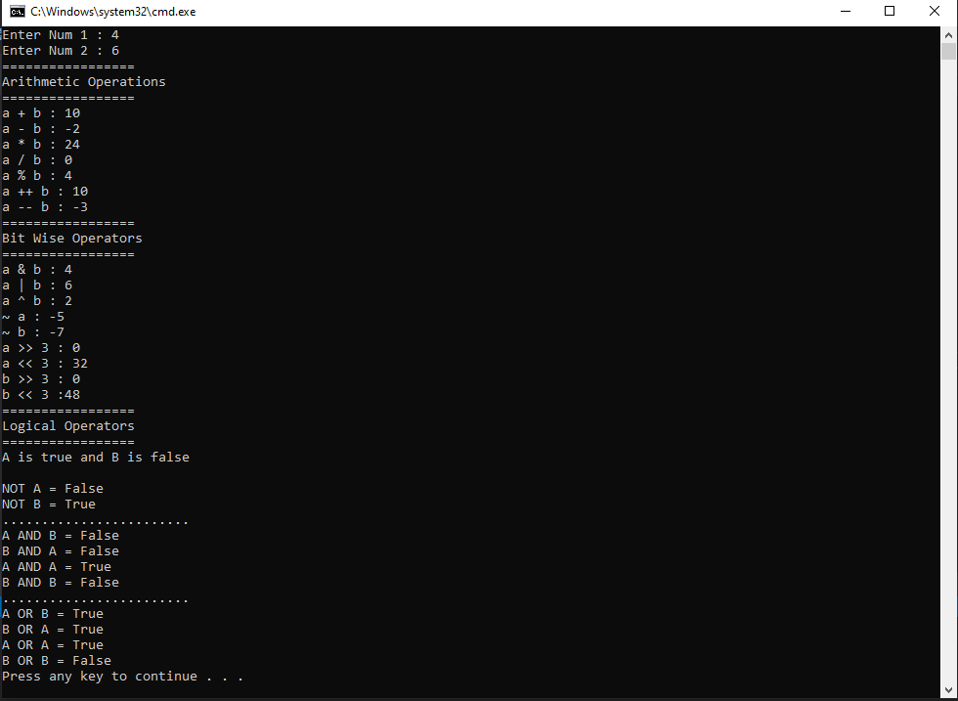

**Task No. 3: Create a simple program to calculate Hypotenuse using Pythagoras theorem**

**c^2 =(a^2 + b^2)**

**Solution:**namespace Lab_5_task_3

{

class Program

{

static void Main(string[] args)

{

int a, b;

Console.Write("Enter a: ");

a = Convert.ToInt32(Console.ReadLine());

Console.Write("Enter b :");

b = Convert.ToInt32(Console.ReadLine());

double sqr = Math.Pow(a, 2);

double power = Math.Pow(b, 2);

Console.WriteLine("Square of a: " + sqr);

Console.WriteLine("Square of b:" + power);

double sqrt = Math.Sqrt(sqr + power);

Console.WriteLine("c^2 =(a^2 + b^2)");

Console.WriteLine("Value of c^2 = " + sqrt);

}

}

}

**Output:**